Beet Seed
Bug Report: Missing or Unclear Hyperlink for Medical License Verification
Bug ID: BUG-OM-01
Component: Content & UI / Legal & Compliance
Severity: Medium (Usability / Legal Compliance)
Priority: Medium

1. Summary
- What: The text phrase "The license can be checked at the link" lacks an active, clickable hyperlink or visual link affordance.
- Where: On “Licenses” page, main section on
- When: When a user attempts to view or click on the text to verify the medical license.

2. Environment
- URL: https://oxford-med.com.ua/en/licenses/
- Operating System: Windows 11 Pro
- Browser: Google Chrome v124.0 (64-bit)
- Resolution: 1920x1080 (Desktop)

3. Pre-conditions
- Active internet connection is available.
- Web browser is open.

4. Steps to Reproduce
- Open the browser and navigate to https://oxford-med.com.ua/en/licenses/
- Scroll to the section displaying licensing information
- Locate the text statement: "The license can be checked at the link".
- Attempt to click on the words "link" or "at the link".

5. Expected Result
The word "link" (or "at the link") should be formatted as a standard, recognizable hyperlink. Clicking it should redirect the user or open the official medical license document/page in a new browser tab.

6. Actual Result
The text "The license can be checked at the link" is displayed as static plain text. There is no active HTML <a> link tag attached, no visual styling indicating clickability, and clicking the text produces no action, leaving the user unable to verify the license.

7. Attachments & Evidence
- Screenshot:
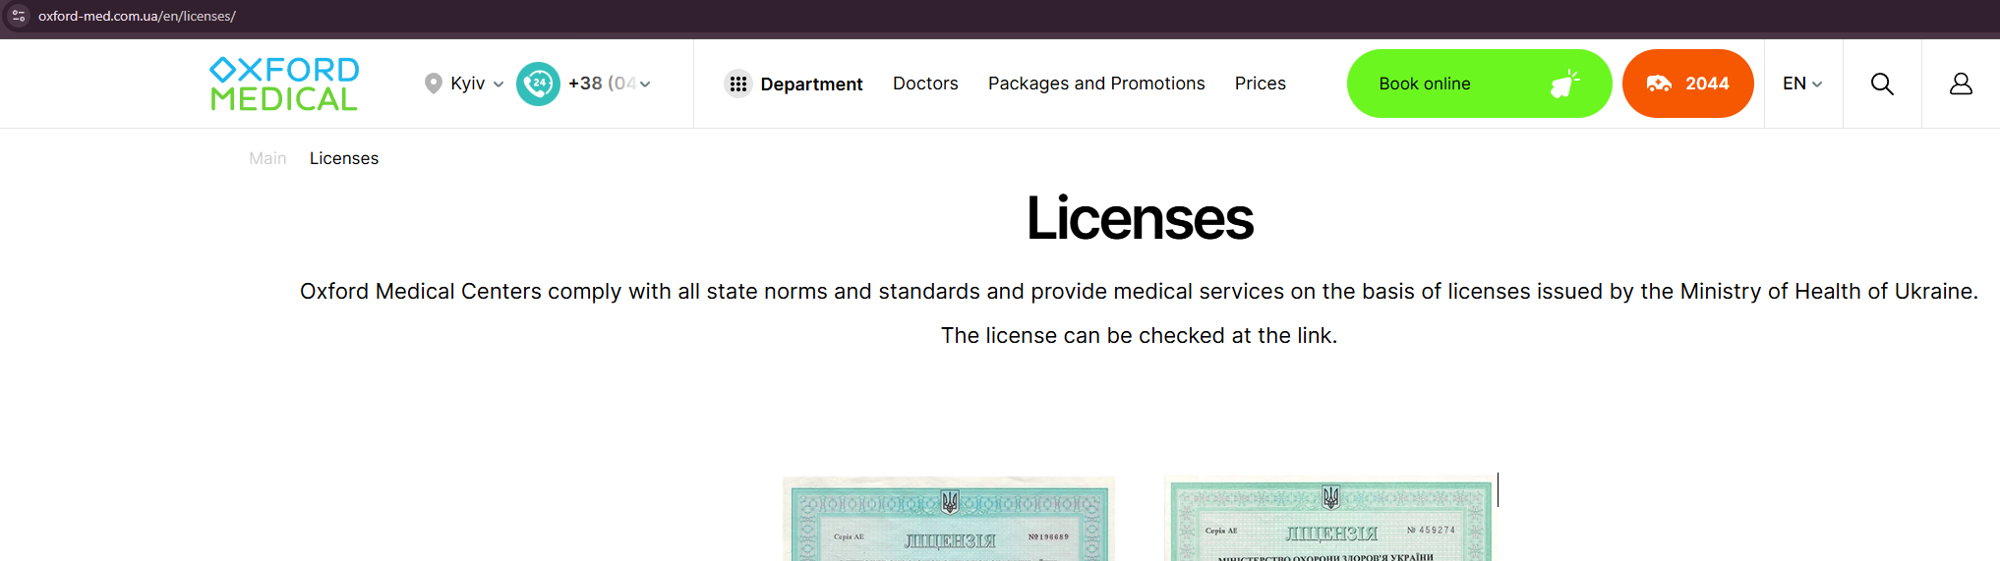

Bug Report: Financial Statements Text Has Active Hover State but Is Unclickable
Bug ID: BUG-OM-02
Component: UI / Compliance & Financial Reports
Severity: Medium
Priority: Medium

1. Summary
- What: Text entries under the "Financial statements" section exhibit interactive hover states (cursor changes to pointer / visual style changes), but clicking them produces no action.
- Where:https://oxford-med.com.ua/en/licenses
- When: When a user hovers over and clicks on any text link/entry within the Financial Statements block.

2. Environment
- URL: https://oxford-med.com.ua/en/licenses/
- Operating System: Windows 11 Pro
- Browser: Google Chrome v124.0 (64-bit)
- Resolution: 1920x1080 (Desktop)

3. Pre-conditions
- Active internet connection is available.
- Web browser is open.

4. Steps to Reproduce
- Open the browser and navigate to https://oxford-med.com.ua/en/licenses/
- Scroll to the Financial Statements section on the page.
- Hover the mouse cursor over any financial statement text line item.
- Observe the visual feedback/cursor state (e.g., cursor changes to pointer or text highlights).
- Click on the text.

5. Expected Result
- If intended as documents: Clicking the text should download financial report file (e.g., PDF) or redirect to a dedicated report page in a new browser tab.
- If intended as static text: The text should not feature a clickable hover state preventing misleading hover effects

6. Actual Result
The text displays a hover effect suggesting it is an interactive link, but clicking on it performs no action. No document opens, no download is triggered
8. Attachments & Evidence
- Screen Recording: https://drive.google.com/file/d/1QXxk0pjqaSdaOwsiewa_y4oo4HmeVZ3d/view?usp=drive_link

Bug Report: Phone Number Input Field Enforces Ukrainian (+380) Country Code Across All Locales
Bug ID: BUG-OM-03
Component: UI / Form Validation & Input Formatting
Severity: Medium
Priority: Medium

1. Summary
- What: The telephone input field automatically forces and locks the Ukrainian country code prefix (+380), preventing users from entering international telephone numbers.
- Where: https://oxford-med.com.ua/en/leave-a-review/ "Leave a review" form.
- When: When a non-Ukrainian user attempts to enter an international phone number to submit feedback or a review.

2. Environment
- URL: https://oxford-med.com.ua/en/leave-a-review
- Operating System: Windows 11 Pro
- Browser: Google Chrome v124.0 (64-bit)
- Resolution: 1920x1080 (Desktop)

3. Pre-conditions
- Active internet connection is available.
- Web browser is open.

4. Steps to Reproduce
- Open the browser and navigate to https://oxford-med.com.ua/en/leave-a-review
- Locate any form containing a phone number input field (e.g., "Book an appointment" or callback popup).
- Focus on the phone number input field.
- Attempt to clear or delete the default +38 prefix.
- Attempt to type an international phone number (e.g., starting with +44, +1, +49).

5. Expected Result
On the English localization (/en/), the phone number input field should either allow entering arbitrary international phone numbers (with flexible country code formats) to accommodate non-Ukrainian patients.

6. Actual Result
The phone number field applies a strict input mask fixed to +38(0..). It automatically overwrites inputs to enforce the Ukrainian calling code and prevents users from deleting +38 or entering foreign phone numbers, making form submission impossible for international users without a Ukrainian phone line.

7. Attachments & Evidence
- Screen Recording: https://drive.google.com/file/d/14LUzOiCZ81O8wuNHvc6TDRvVxVrGH-dr/view?usp=drive_link

Bug Report: Untranslated Ukrainian Text Section on English Pricing Page
Bug ID: BUG-OM-04
Component: UI / Localization & Content
Severity: Minor
Priority: Medium

1. Summary
- What: The section header and content block "Пакетні та Акційні пропозиції" is displayed in Ukrainian instead of being translated to English.
- Where: https://oxford-med.com.ua/en/price Pricing section / Package & Promotional Offers block.
- When: When a user accesses the English locale (/en/) version of the Price page.

2. Environment
- URL: https://oxford-med.com.ua/en/price/
- Operating System: Windows 11 Pro
- Browser: Google Chrome v124.0 (64-bit)
- Resolution: 1920x1080 (Desktop)

3. Pre-conditions
- Active internet connection is available.
- Web browser is open.

4. Steps to Reproduce
- Open the browser and navigate to https://oxford-med.com.ua/en/price
- Scroll down through the price listings to locate the special offers/packages section.
- Observe the section heading displaying "Пакетні та Акційні пропозиції".

5. Expected Result
All text content on the English locale (/en/price/) should be fully translated into English. The header should display an equivalent English title such as "Package and Promotional Offers".

6. Actual Result
The section header "Пакетні та Акційні пропозиції" and its associated sub-elements remain untranslated in Ukrainian on the English version of the site.

7. Attachments & Evidence
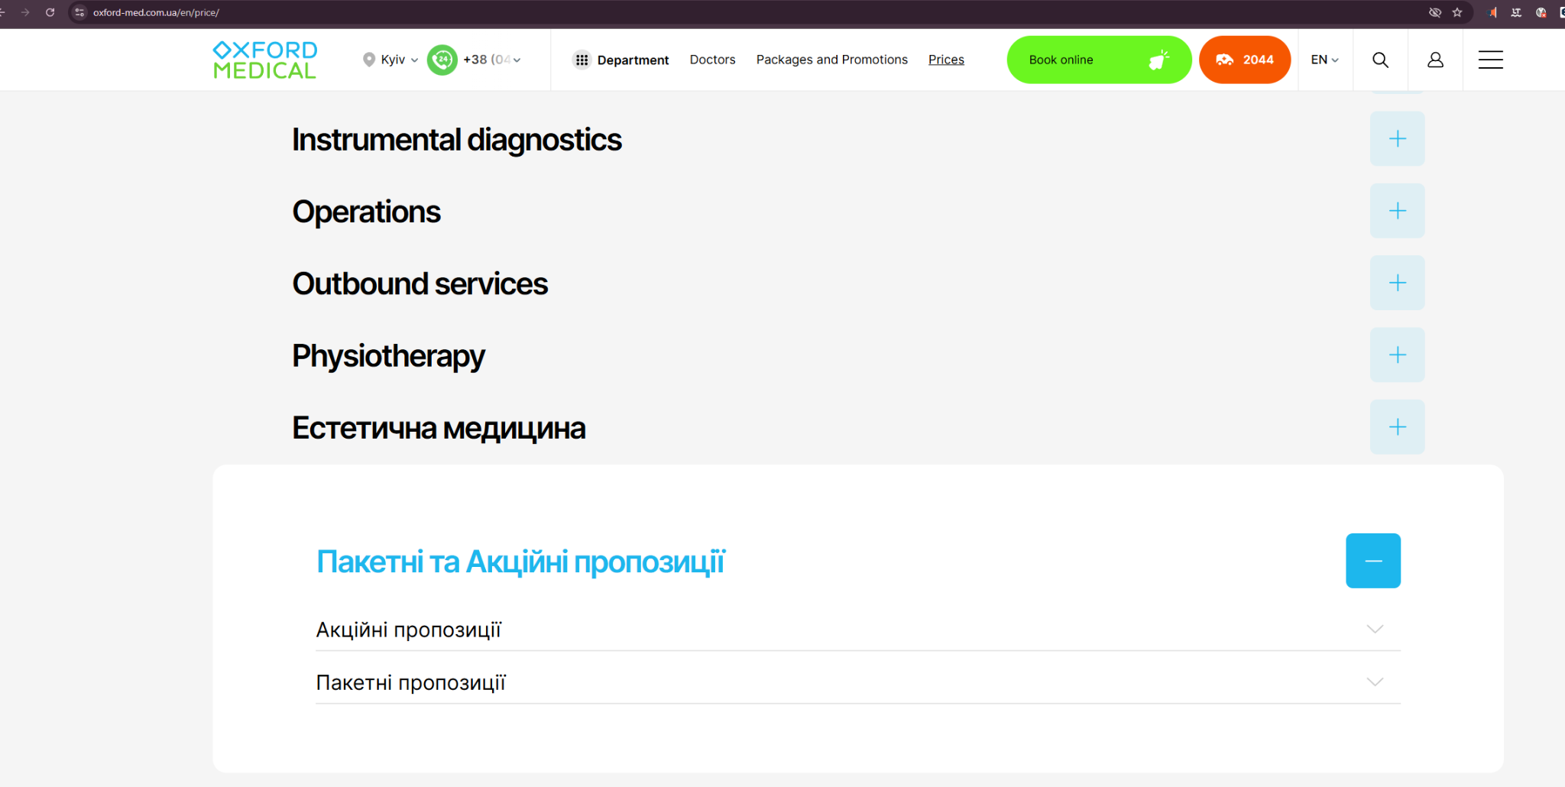

Bug Report: Missing Hover Overlay CTA Button on First Three Doctor Profile Cards
Bug ID: BUG-OM-05
Component: UI / Doctor Profile Cards & Appointment CTA
Severity: Minor
Priority: Medium

1. Summary
- What: Hovering over the profile cards for the first three listed doctors fails to display the hidden "Make an appointment" CTA button, while the fourth card functions correctly.
- Where:https://oxford-med.com.ua/en/services/vyezdnie-uslugi/neotlozhnaya_pomosch/) Emergency Care Doctors / Specialists section.
- When: When a user hovers the mouse cursor over any of the first three doctor profile photos on the page.

2. Environment
- URL:https://oxford-med.com.ua/en/services/vyezdnie-uslugi/neotlozhnaya_pomosch/
- Operating System: Windows 11 Pro
- Browser: Google Chrome
- Resolution / Device: 1920x1080 (Desktop)

3. Pre-conditions
- Active internet connection is available.
- Web browser is open.
- User has navigated to https://oxford-med.com.ua/en/services/vyezdnie-uslugi/neotlozhnaya_pomosch/

4. Steps to Reproduce
- Scroll down to the doctors/specialists section.
- Hover the mouse cursor over each of the first three doctor profile photos.
- Observe the absence of the hidden "Make an appointment" button on hover.
- Hover over the fourth doctor profile photo for comparison.

5. Expected Result
Hovering over any of the first three doctor profile cards should trigger the standard visual hover effect, displaying the hidden "Make an appointment" CTA button (matching the working behavior of the fourth card).

6. Actual Result
Hovering over the photos of the first three doctors does not reveal the hidden "Make an appointment" button. The cards remain static without a hover overlay, preventing quick appointment booking for these specific doctors.

7. Attachments & Evidence
- Screen Recording: https://drive.google.com/file/d/1xW6TOYU7pXUQogMjiGTsGkUVH_k70iN-/view?usp=drive_link

Beet Sprout
Проведи кросбраузерне тестування знайдених раніше багів у трьох різних браузерах.

3. Додай результати до зафіксованих раніше багів.

Cross-browser testing for all previously reported bugs was conducted on Vivaldi, Maxthon, and Tor Browser. The defects remained fully reproducible across all three browsers, with no noticeable differences in behavior or visual presentation compared to the main target browsers."

Mighty Beet
(in progress)За допомогою Developer Tools зафіксуй використаний шрифт, його розмір, колір та колір бекграунду наступних елементів сайту Оксфорд Медикал:

номер телефону у хедері

font-family: Inter, sans-serif;
font-size: .936vw;
color: #000;
background: #fff;
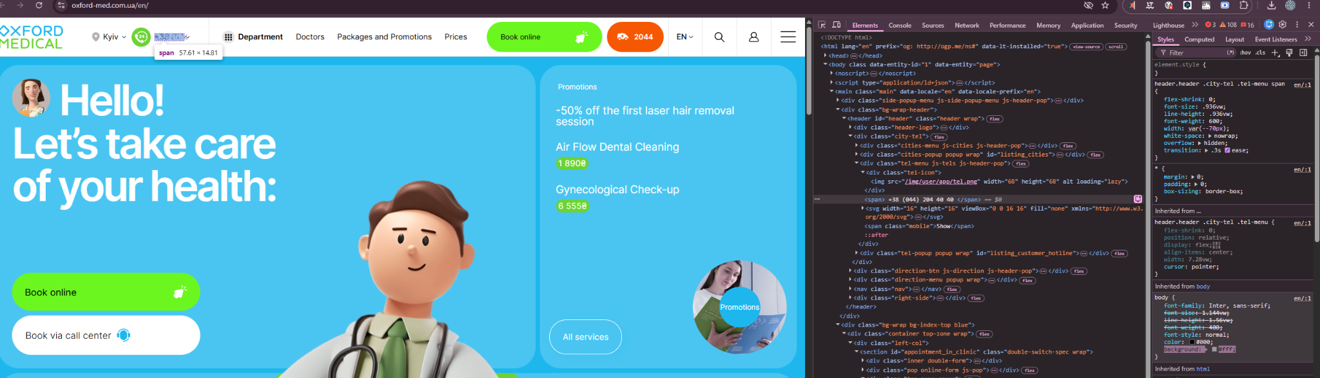

ім’я асистента при виклику чата допомоги

font-family: "Open Sans", sans-serif;
font-size: 32px;
color: rgb(255, 255, 255);

